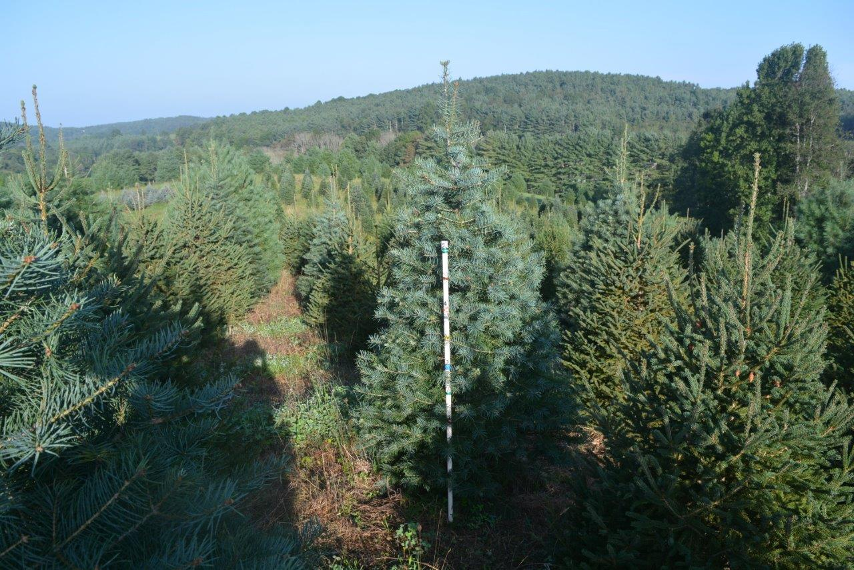

Abies concolor HEAVY SHEERED 6’ Leyland cypress HEAVY SHEERED 7’

Leyland cypress 10’ Picea abies SEMI SHEERED 10’

Picea glauca SEMI SHEERED 5’ Pinus strobus SEMI SHEERED 7’

Green Giant 8’ Green Giant 10’

Picea abies 10’  
Picea aboes 7’